Homework 3

David Zhao

CSCE 1040

Design Doc

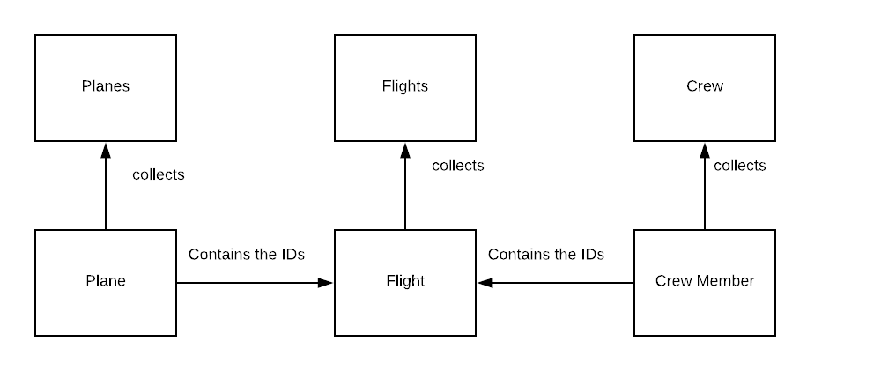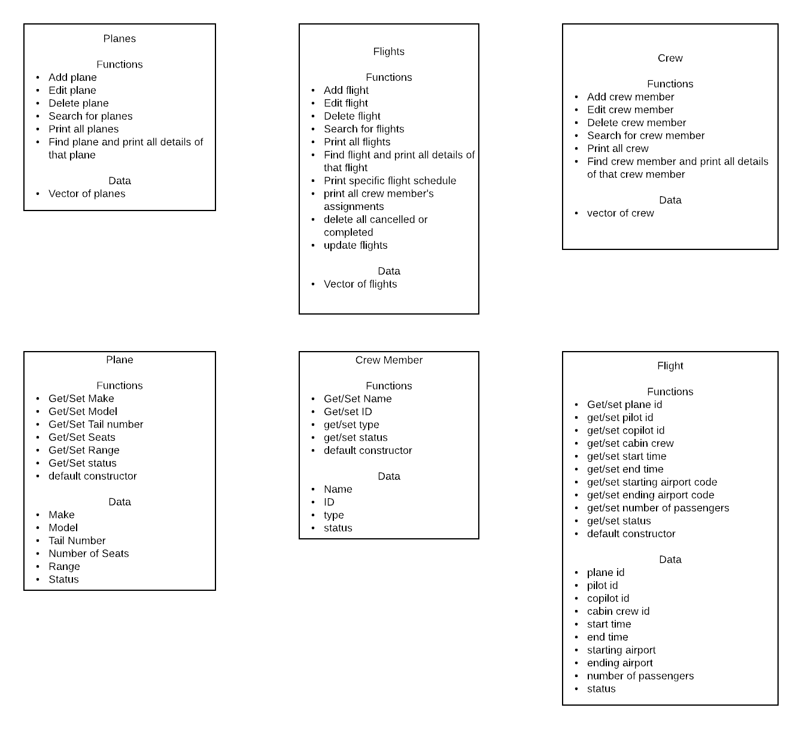

**Plane:**

String make, tailNum, status

Int model, seatsNum, range

Accessors and mutators for all of the above data

Default constructor sets all strings to “ “ and all integers to 0

**Planes:**

Vector <plane> planeList

Int searchPlane(string planeNum)

iterates through the vector until it finds the plane that returns planeNum with getPlane(), then returns the iterating counter in the for loop

if plane is not found, returns -1

bool addPlane(plane newPlane)

use searchPlane with the given newPlane to see if any planes match. If not,

push_back newPlane to vector of planes and return true and store data

else return false

bool editPlane(plane edited)

call searchPlane using the plane number from edited, then use that as planeList[iterator] to find the plane

if plane not found, then return false

then check to see if get functions return default values from edited; if so, don’t replace for that value. If functions return non-default values, use set functions on planeList[iterator]. Then return true and store data

bool deletePlane(string planeNum)

call searchPlane using planeNum

if searchPlane returns -1, return false

else, planeList.erase(planeList.begin() + number from searchPlane – 1) and store data

void printPlanes()

iterates through the vector (probably with .at() and a for loop) and prints out the get function for each one

bool printEntry(string planeID)

uses searchPlane(planeID) to find the plane, returns false if plane not found

if plane found, print out all the accessors and return true

**Crew Member:**

String name, type, status

Int id (or long, depends on how long expected ids are)

Accessors and mutators for all of the above

Default constructor sets strings to “ “ and int/float to 0

**Crew:**

Vector <crewmember> crewList

Int searchCrew(int/long crewID)

iterates through the vector until it finds the crew member that returns crewID with getCrew(), then returns the iterating counter in the for loop

if plane is not found, returns -1

bool addCrew(crewmember newCrew)

use searchCrew with the given newCrew to see if any planes match (probably just gonna use getID and use that). If not,

push_back newCrew to vector of crew members and return true and store data

else return false

bool editCrew(crew edited)

call searchCrew using the crew ID from edited, then use that as crewList[iterator] to find the crew member

if crew member not found, then return false

then check to see if get functions return default values from edited; if so, don’t replace for that value. If functions return non-default values, use set functions on crewList[iterator]. Then return true and store data

bool deleteCrew(int/long crewID)

call searchCrew using crewID

if searchCrew returns -1, return false

else, crewList.erase(crewList.begin() + number from searchFlights – 1 (not sure if -1 is necessary, clarify later)) and store data

void printCrew()

iterates through the vector (probably with .at() and a for loop) and prints out the get function for each one

bool printEntry(int/long crewID)

uses searchCrew(crewID) to find the crew member, returns false if crew member not found

if crew member found, print out all the accessors and return true

**Flight:**

String planeID, startPort, endPort, status

Int pilotID, copilotID, cabin1, cabin2, cabin3, startTime, endTime, numPass, flightID

Accessors and mutators for all of the above

Default constructor sets strings to “ “ and ints to 0

**Flights:**

Vector <flight> flightList

Int searchFlights(int/long flightID)

iterates through the vector until it finds the flight that returns the flightID with getFlightID(), then returns the iterating counter in the for loop

if plane is not found, returns -1

bool addFlight (flight newFlight)

use searchflight with the given newFlight to see if any flights match (probably just gonna use getID and use that) IDs, if the plane is busy, if the passengers of newFlight are less than the plane’s seats, and that the crew is not already assigned. Also check to see if the crew members are in valid positions. If not,

push_back newFlight to vector of flights and return true and store data

else return false

bool editFlight(flight edited)

call searchFlight using the flight ID from edited, then use that as flightList[iterator] to find the flight

if flight not found, then return false

then check to see if get functions return default values from edited; if so, don’t replace for that value. If functions return non-default values, use set functions on flightList[iterator]. Then return true and store data

bool deleteFlight(int flightID)

call searchFlights using flightID

if searchFlight returns -1, return false

else, flightList.erase(flightList.begin() + number from searchFlights – 1 (not sure if -1 is necessary, clarify later)) and store data

void printFlights()

iterates through the vector (probably with .at() and a for loop) and prints out the get function for each one

bool printEntry(int flightID)

uses searchFlights(flightID) to find the flight, returns false if flight not found

if flight found, print out all the accessors and return true

bool printFlightsAssignment(int planeID)

loop through vector and find all flights with planeID as the plane id

if those flights are active, print those flights’ start and end times, return true at end of looping

if none are found, return false

bool printCrewAssignment(int/long crewID)

loop through vector and find all flights with crewID as one of the crew members’ id

if those flights are active, print those flights’ start and end times, return true at end of looping

if none are found, return false

bool printFlightStatus(string compareStatus)

loop through vector and find all flights with status == compareStatus

print out flightIDs, return true at end of loop

else, return false

bool deleteFlightStatus(string conStatus)

loop through vector and find all flights with status == conStatus

delete those with erase(flightList.begin() + iterator - 1), restart iterator

return true if loop succeeds at all (check iterator status)

else return false

void updateFlights()

check current time

loop through flightsList to check if any of their end times are before current time

if so, update those statuses

**Menu:**

Options: Add a crew member, add a plane, add a flight, delete a crew member, delete a plane, delete a flight, edit a crew member, edit a plane, edit a flight, find a crew member, find a plane, find a flight, print all crew members, print all planes, print all flights, print all details of a crew member, print all details of a plane, print all details of a flight, print assignment schedule for a flight, print assignment schedule for a crew member, print flights from status, delete cancelled flights, delete removed flights, update flights

Each of the above is just a combination of the methods and functions of the classes

**Loading and Storing:**

For storing data:

Print out crew data, then plane data, then flight data with streams and newlines inbetween each bit of data

Also print number of each type of data before looping the print

For loading data:

Use primarily cin and for loops to grab data from the file, using a cin to grab the number of iterations needed

**Post-mortem:**

Honestly, not much was hard about this assignment. Most of the functions implemented here are much easier thanks to the use of vectors, though I definitely need to review some things. Completing the assignment on time was also rather easy, as I started about 3 days before it was due and paced myself. I think the most difficult part of this entire assignment was trying to figure out how I wanted my searchFlight function to work; did I want to use a new variable as flightID or did I want to be able to search by plane number and crew? Ultimately, I decided to use flightID, as some flights may end up being repeats based on plane number and crew.